GROSS MOTOR ACTIVITIES:

Below are some suggested motor activities that you may incorporate in your home learning. Please read through the options and choose activities that you think may be helpful for your child. Some activities allow students to complete them independently, some are for adults and students to do together, and some are to guide the adult to help the student. Please follow your own child’s abilities, precautions, or restrictions for movements.

Activity 1 | Plastic Bottle Bowling
Materials | 5-10 empty plastic bottles, soccer or playground ball, tape
Skills Targeted | Strength, coordination, balance
Instructions: | - Create a home bowling alley in a hallway, or backyard.  - Use tape (or string) to mark where the bottles should go.  - Roll the ball toward the “bottle bowling pins.”  - Repeat until all of the pins are down.  - Have the child set the pins back up for another round.
Modifications | 1. Child could also kick a soft ball at the pins to knock them down.  2. Game could be played in sitting with either rolling or kicking the ball.  3. You can vary the distance from the pins to make it easier or harder.

Activity 2 | Balloon Volleyball
Materials | Balloons, some string/yarn
Skills Targeted | Coordination, balance, ball skills
Instructions: | 1. Blow up a balloon.  2. Place a length string or yarn to mark the center line or “net” on the floor.  - Hit the balloon back and forth with your child.  - How many times can you hit it back and forth?
Modifications | - Can be played in sitting or standing  - For a challenge: child can play both sides of the net, running back and forth over the line to hit the balloon.  - Include siblings and create teams.  - For a challenge, use a different body part to keep the balloon in the air—your feet, elbow, etc.

Activity 3 | Animal Walks
Materials | Your body
Skills Targeted | Upper and lower body strength and coordination and motor imitation
Instructions: | Pick an animal to imitate (easy animals to pick from: Frog, bear, crab, bunny, horse, penguin)  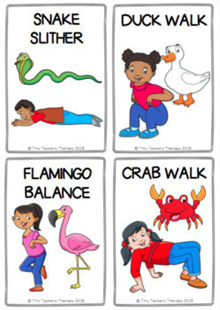
Modifications: | - These can be done in sitting with an emphasis on the arm movements like chomping like an alligator, elephant trunk motion, etc.  - You can build this into your routine. For example, have your child walk like a selected animal to go brush their teeth every evening.

